**AWS EC2 LINUX INSTANCE**

1. create linux instance

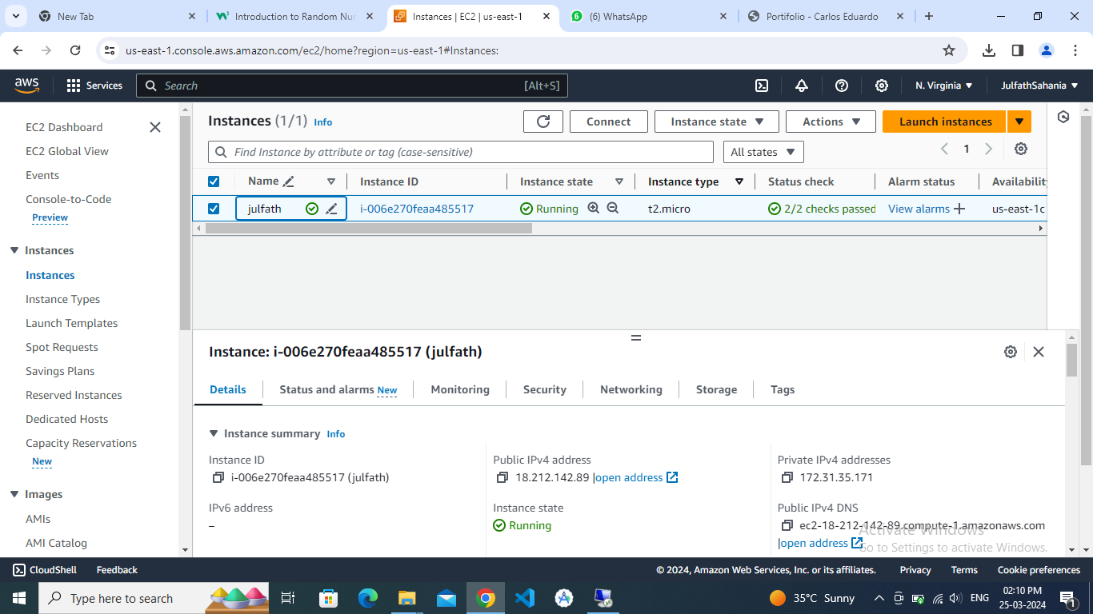

2- install apache software #yum install httpd

3-Root user:#sudo su

Apache state: #service httpd status

To get it active: #service httpd start

Default page

LAUNCH AN INSTANCE

PUTTY CONFIGURATION ->HOST ADDRESS IN SESSION -> SSH -> AUTH -> CREDENTIALS -> PRIVATE KEY FILE FOR AUTHENTICATION -> UPLOAD KEY FILE

LOGIN AS: ec2-user

🡪change to root user normal user-$ root user-#

🡪install apache through command

🡪run the instance ip address in the browser should come in test page



🡪location : cd /var/www/html(-sensitive folder only accessed by root folder)

🡪pwd

to copy the files

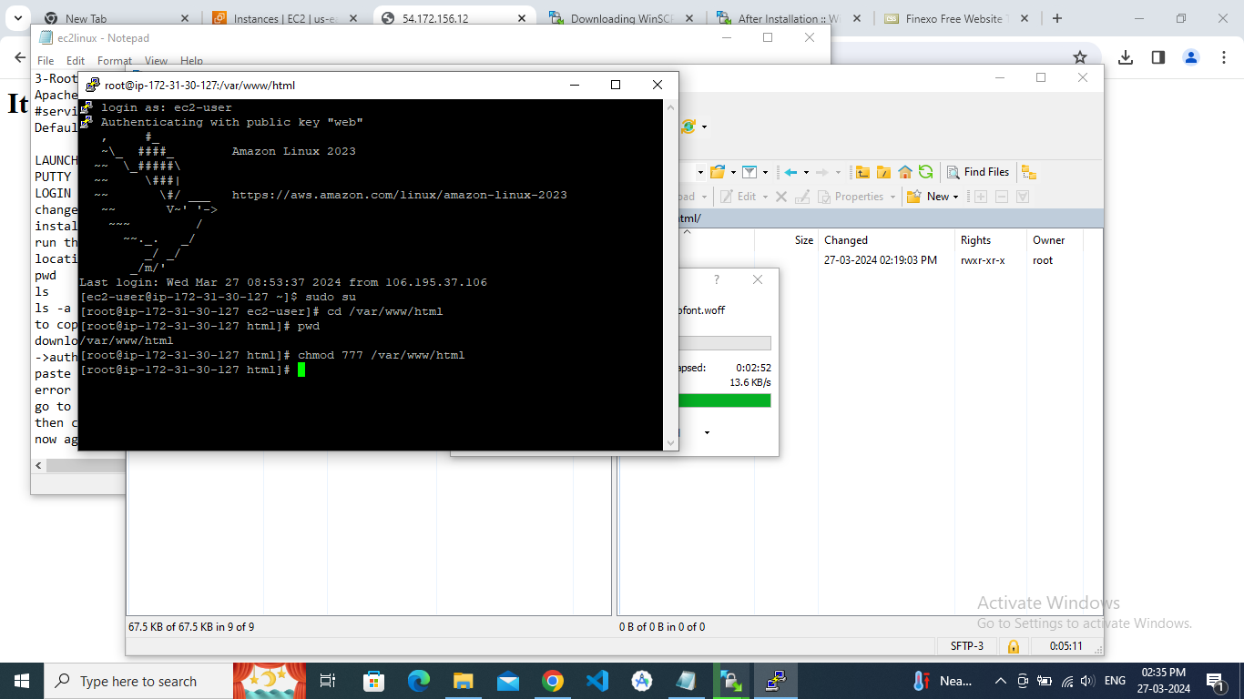

🡪download winscp-> new tab -> SFTP ->host name-server ip address->user name->ec2-user->pswd->advanced ->auth->private key upload->login-> copy the files in windows -> open directory in ec2

🡪paste

🡪error occurs

🡪go to putty config type chmod 777 /var/www/html

🡪then copy and run ls in putty

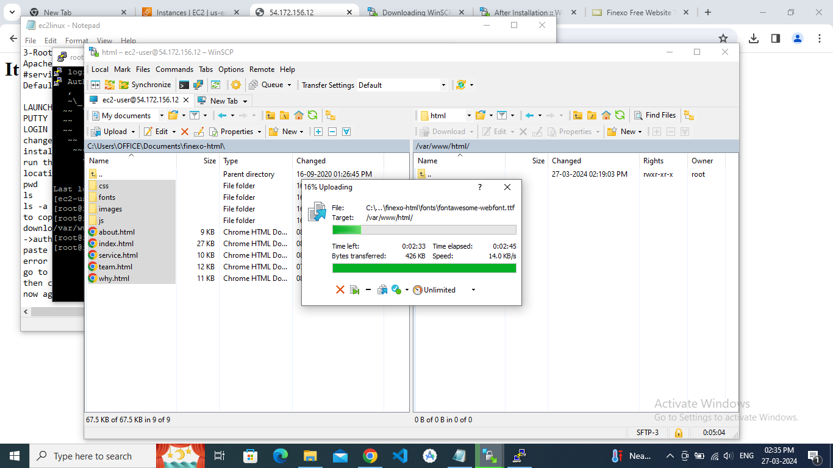

🡪now again copy the ip address and run in browser

